Project: Module 4.2 Assignment – Test Plan
Course: CSD380 DevOps
Description: For this assignment, you will be drafting a test plan based on the business requirements presented in the “Todo Business Requirements” document (linked below). The test plan must include at least 5 functional tests and those tests must encompass the requirements in the document.
Date: 2026/01/11
To complete the test case plan, fill out the information for Project, Course, Description and Date in the header below.
.
TABLE OF CONTENTS
Test Plan 1 2
Test Plan 2 3
Test Plan 3 3
Test Plan 4 4
Test Plan 5 4

For each test, the developer should: provide a test description, a test objective, the developer name and date tested. For each step, fill out the actions to be taken and describe the expected results, and indicate yes or no for each step depending upon the result. The peer tester should provide their name, date tested, indicate yes or no for each step depending upon the result, and a screenshot (thumbnail) of the result.

Test 1 | Access Website Using Standard URL
 | Test Objective: Allow users to visit the website through https://buwebdev.github.io/todo/ | Developer:  Date tested: Jackson<2026/01/11> | Peer tester: M. Michaels  Date tested: 2026/01/18
Step | Action | Expected results: | Developer pass/fail | Tester pass/fail  + Screenshot
1 | Open a web browser | Browser open | yes | Yes, Chrome open 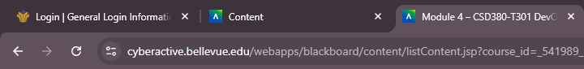
2 | Go to https://buwebdev.github.io/todo/ | Link works | yes | Yes – loaded  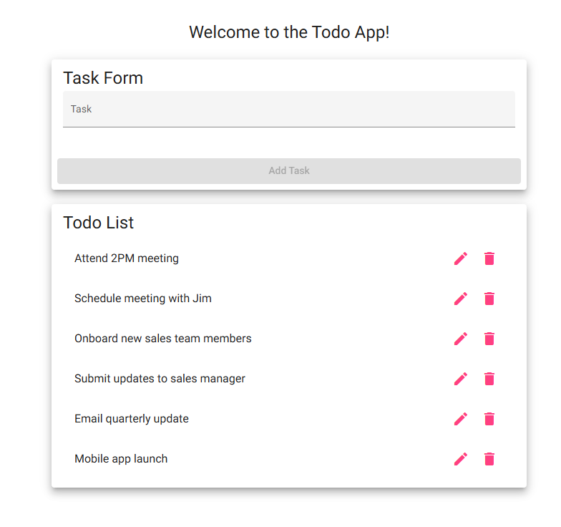
3 | Confirm pages load | Page loads correctly | yes | Yes, loaded
4 | Refresh the window | Page continues to work | yes | Yes – refresh loads the same page
Comments | The main link and page load correctly. The test sufficiently tells if the page loads through a standard URL. The page loads correctly in the Chrome browser from scratch or with a refresh.

Test 2 | View List of ToDo Items
 | Test Objective: View a list of todo tasks | Developer:  Date tested: Jackson <2026/01/11> | Peer tester: M. Michaels  Date tested: 2026/01/18
Step | Action | Expected results: | Developer pass/fail | Tester pass/fail
1 | Load the Todo homepage | Homepage loads and displays | yes | Yes  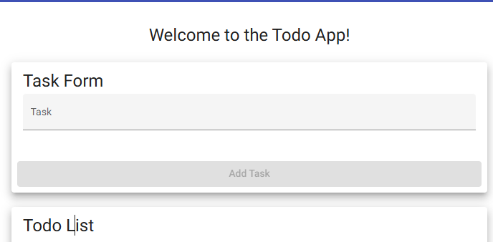
2 | Observe the todo list | List is visible and easy to access | yes | Yes  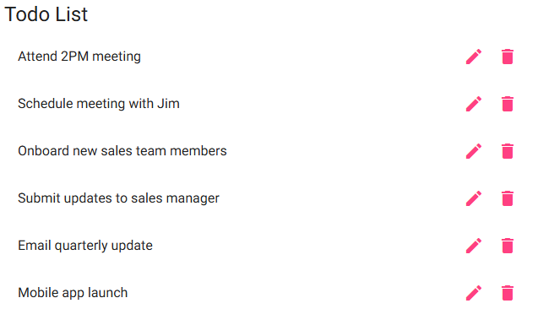
Comments | Todo list is fully visible and accessible. It is the homepage and loads immediately when the page loads. All tasks load at the same time.

Test 3 | Create a New Todo Item
 | Test Objective: | Developer:  Date tested: Jackson <2026/01/11> | Peer tester: M. Michaels  Date tested: 2026/01/18
Step | Action | Expected results: | Developer pass/fail | Tester pass/fail
1 | Click inside the Todo input field | Allows for typing | yes | Yes  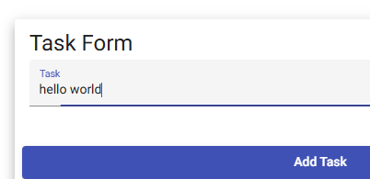
2 | Enter a task | Text is taken | yes | Yes
3 | Press Add Task | New item is created | yes | Yes
Comments | Text can be entered into the fields and once the task is added, it appears on the task list.

Test 4 | Prevent Empty Todo Submission
 | Test Objective: Prevent users from submitting a task form without entering a todo item | Developer:  Date tested: Jackson <2026/01/11> | Peer tester: M. Michaels  Date tested: 2026/01/18
Step | Action | Expected results: | Developer pass/fail | Tester pass/fail
1 | Click inside the Todo input field | Allows for typing | yes | Yes  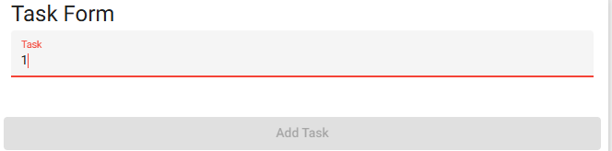
2 | Leave the input field empty | Input field empty | yes | Yes  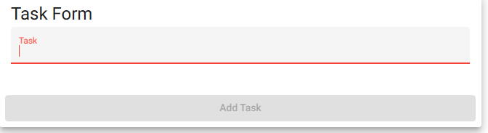
3 | Try to Add Task | Doesn’t let you press the button | yes | Yes  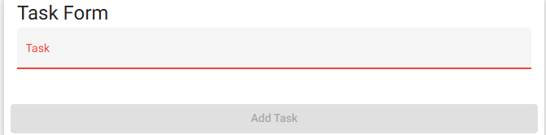
Comments | Text can be entered. However, it doesn’t specify what type of text it has to be. When there is no text or the text is not recognized (e.g. just a random number), the Add Task button is not active.

Test 5 | Delete a Todo Item
 | Test Objective: Delete todo task item | Developer:  Date tested: Jackson <2026/01/11> | Peer tester: M. Michaels  Date tested: 2026/01/18
Step | Action | Expected results: | Developer pass/fail | Tester pass/fail
1 | Locate an existing Todo item | Find items on list | yes | Yes
2 | Click the delete (X) button | Todo item is deleted | yes | Yes  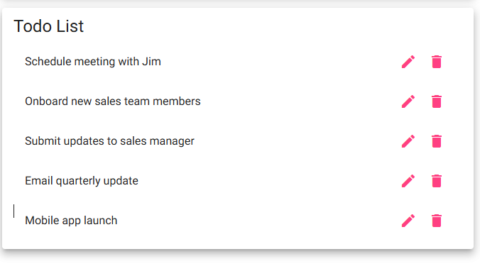
Comments | Adding and deleting tasks works correctly. A task can be deleted and then added again.

